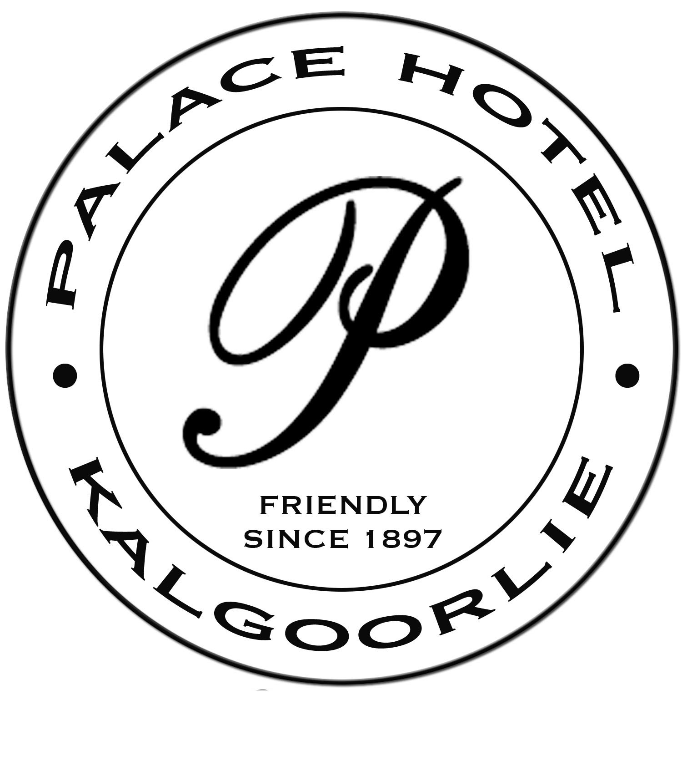

THE BALCONY BAR & RESTAURANT

Open 7 nights from 4 pm
(except most public holidays)

EARLY BIRD MENU AVAILABLE
4pm to 6pm
For early bird diners, tables on the Balcony need to be made available by 7pm (Subject to peak periods)

MAIN MENU
5pm onwards

Please Note:
“We are sorry, we do not do separate payments/billing”

Functions
Please email our functions coordinator at functions@palacehotel.com.au
to organise your function

Early Bird Menu
Available from 4pm to 6pm
Early bird tables need to be available by 7pm
(subject to peak times)

Chef’s Tasting Plate – To share - $34
Selection includes, S&P Squid, Prawns, Thai Beef , Dips, Breads, Olives , Fetta & more.

Entree
Soup of the Day with Bread - $10

Thai Beef Salad - $21
Warm marinated premium eye fillet, with salad greens & lime and ginger dressing

Chicken & Blue Cheese Tart - $19
Filo basket with sliced chicken, fresh poached pear & a mild creamy blue cheese sauce

Spinach & Ricotta Ravioli - $18
With olives, spinach, pine nuts & a tomato & basil butter

Mains
Medallion of Premium Beef Eye Fillet $33
Lamb Cutlets $35
Served with Mash
Choice of sauces, Red Wine, Pepper, Mushroom

Pork Belly served with Parisienne potato & salad with Caramel Glaze $32

Pappardelle Pasta - Chicken $28 or Vegetarian $26
Creamy sundried tomato, spinach, & basil sauce or Tomato salsa

Tempura Barramundi & Chips $28
Served with a side salad & tartare sauce

Dessert - $12
Pavlova, served with whipped cream and seasonal fruits
Cheesecake of the day
Sticky Date pudding with vanilla ice cream
Vanilla Ice Cream Sundae, with strawberry, chocolate or caramel topping

Breads

Crusty Cob Loaf – serves 2 or more
Plain Crusty - $10
Garlic - $12
Cheese & Chilli - $14
Dukkah, Balsamic/Olive oil & Olives - $16

Oysters - order groups of - 3, 6 or 12

Natural - $3.60 each
Kilpatrick - $3.90each
Mornay - $3.90 each
Mixed Dozen - $3.90 each

Oyster Shooters
Served natural in a shot glass
Tomato & tabasco $3.90 each
With Vodka $6.50 each

Entrees

Chef’s Tasting Plate – To Share $40
Selection includes – salt & pepper squid, prawns , thai beef, dips, olives, fetta & more

Soup of the Day – Served with crusty bread - $12

Thai Beef Salad - $22
Warm marinated premium eye fillet, thai style salad, lime & ginger dressing

Spinach & Ricotta Ravioli - $22
With olives, spinach, pine nuts & a tomato & basil butter

Chicken, Pear & Blue Cheese Tart $24
Filo basket filled with chicken, pear & a creamy blue cheese sauce

Pork Belly - $22
Served with Waldorf Salad

Seared Scallops - $28
With crispy prosciutto & a tangy hollandaise sauce

King Prawns with steamed Rice - $24
Sauce: Creamy garlic sauce or Chilli salsa

Cashew Crumbed King Prawns - $24
Prawns coated in crushed cashew nuts, a piquant marie rose dressing with salad

Salt & Pepper Squid - $22
Served on salad greens with aioli dipping sauce

Vegetarian Tart - $22
Sautéed asparagus, mushroom & spinach with a roasted red pepper coulis

Beef, Lamb, Pork

Eye Fillet Scotch Fillet
Served with Mash Potato Served with Mash Potato
200grams - $36 400 grams - $46
400 grams - $48
Sauces: Red Wine or Mushroom or Béarnaise or Creamy Garlic or Blue Cheese
Pepper Steak
Served with Creamy Mash Potato & Brandy Sauce
Choose: Eye Fillet -200g $36 or 400g $48 or Scotch Fillet - 400g $46

Beef & Reef
Served with Herbed Roast Potato
Add: Prawns & Scallops in a rich creamy sauce - $12
Choose: Eye Fillet 200g $36 or 400g $48 or Scotch Fillet 400g $46

Rack of Lamb $42
With a dukkah crust, red pepper, spinach, & beetroot jam, potato & bacon croquette & a minted béarnaise sauce

Pork Belly - $39
Caramelized with roast parisienne potato, apple & celery salad & pickled walnut

The Palace Trio - $45
Medallion of prime beef eye fillet, lamb cutlet & pork belly,
served with, mushroom sauce, minted hollandaise, and caramel glaze, with mash potato & steamed julienne of vegetables.

Pasta
Pappardelle Pasta
Choice of:
Chicken ~ Sundried tomato, spinach & basil creamy sauce - $35
Seafood ~ Salmon, prawn & scallops with a creamy herb sauce - $37
Vegetarian ~ Steamed vegetables in a creamy garlic sauce or tomato salsa - $32

Chicken & Duck
Supreme of Chicken - $39
Chicken breast, filled with camembert & spinach
Served with potato bake & hollandaise sauce
Oceanic Chicken - $42
Chicken breast topped with prawns, scallops & a rich creamy sauce,
served with a crispy potato rosti
Crispy Roast Duck -$42
Served with asian greens & steamed rice with a plum, port & ginger sauce
or
Served with mash, wilted spinach & julienne vegetables & creamy pepper sauce

Salads
Sweet Potato, Spinach, & Soft Fetta Salad – $27
With cucumber, asparagus, lettuce, beans, olives, cherry tomato & toasted cashews.
With a tangy citrus vinaigrette
Add Chicken strips $32 or King prawns $34
Salt & pepper squid $34 or Marinated spicy beef $34
Thai Beef Salad - $34
Marinated with Thai spices, warm premium eye fillet of beef strips, with seasonal garden salad with a tangy lime & ginger dressing.

Seafood

Crispy Skin Salmon Fillet -$39
Served with Spinach Linguini with saffron, cucumber & caper beurre blanc
King Prawns -$38
Creamy garlic sauce & steamed rice or Chilli salsa & steamed rice
King George Whiting -$42
Tempura fillets, served with 2 dipping sauces, side salad, caper berry’s & chips
Sauces: Creamy dill & Japanese style soy & sesame
Barramundi Fillets with Citrus and Almond Crust - $38
Creamy Mash or Steamed Rice & julienne vegetables, & a lemon & chive sauce
Cashew Crumbed King Prawns -$38
Prawns coated in freshly crushed cashew nuts, salad & a piquant Marie Rose dressing

Salt & Pepper Squid -$36
Served on salad greens with lime aioli dipping sauce

Chef’s Tasting Plate -$40
Selection includes S&P squid, prawns, thai beef strips, dips, olives, fetta,
turkish bread & more

Sides
Salad $12: Greek or Garden or Sweet Potato
Vegetables $12: Steamed Vegetables with hollandaise sauce
Potato $8: Mash ~ Chips ~ Boiled Potato ~ Herb Roast Potato
Rice $5: Steamed Rice

Dessert

Sticky Date Pudding $16
With vanilla ice-cream

Gourmet Ice-cream Sundae $14
Served in an old fashioned sundae glass
With pieces of violet crumble,
Sprinkles, whipped cream & your choice of topping

Pavlova $16
Served with whipped cream & seasonal fruit

Cheesecake of the day $16
Ask the wait-staff for today’s flavour

Chocolate & Baileys Bavarois $16
A light chocolate & baileys mousse style dessert with fresh strawberries & cream

Australian Cheese Board $25
Selection of cheese, nuts, fruit & crackers

Kids Menu
For Juniors Under 12

Fish & Chips $10

Chicken Nuggets & Chips $10

Pappardelle Pasta $12
With Chicken in a Creamy Sauce

Chicken Breast $12
With Steamed Vegetables

Chips & Gravy $8

Wedges & Sour Cream $10

Desserts

Ice-Cream $5

Ice-Cream Sundae $8

Bottled Drinks
Ginger Beer
Matso’s Brewery – Broome

Tap Beer & Cider
Heineken , 150 Lashes
Iron Jack , Gold , Rogers
Swan Draft, Hahn Super Dry,
Furphy’s
Spirits - Pre-Mix
Smirnoff Ice Red (Stubbie)
Canadian Club & Dry (Stubbie)
Bundaberg Rum & Cola (Can)
Canadian Club & Dry
( Stubbie)
Jim Beam & Cola (Can)
Jack Daniels & Cola(Stubbie)
Cruisers ~ Various flavours

Cider
Strongbow
Sweet, Dry, Original
Rekorderlig 500ml –
Strawberry & Lime
Pear Cider
International Beer
Heineken
Peroni Nastro Azzurro 5.1
Corona
Guinness
Miller Chill

Australian Beer
Light Strength
Hahn Premium Light

Mid Strength Beer
Hahn Super Dry 3.5(Low Carb)
Rogers – Little Creatures
Great Northern
Heineken 3
Gold

Australian Boutique Beer
Crown Lager
James Boags Premium
Little Creatures Pale Ale
Redback Original
Coopers – Original Pale Ale

Australian Beer
Carlton Dry
Hahn Super Dry (Low Carb)

Red
A selection of vintage & limited edition red wine is also available.

Bottle Glass
House Red $26 $6.50

Classic Dry Red Houghton Quills – Swan Valley $29 $7.00

Shiraz Binduli Wines - Kalgoorlie $26 $6.50
Brookland Valley - Verse 1 - MR $38 $9.50
Leeuwin Estate – Siblings - MR $54
Cape Mentelle – M R $43
Brown Hill – Chaffers M.River $38 $9.50
Wise Eagle Bay – MR $73

Merlot Yilgarnia – Denmark $44

Cabernet Sauvignon Alkoomi – Frankland River $61
Brown Hill - Hannans MR $38 $9.50
St Johns Single Vineyard – M R $55

Cabernet Merlot Voyager Est - Girt by Sea –MR $58
Brown Hill – Trafalgar $49 $10
Amberley – M R $44
Goundrey Homestead- Nannup $36 $9
Vasse Felix - Cowaramup $60

Pinot Noir Millbrook- Great Southern WA $60 $13
5 Trees – Pemberton $45

Cabernet Malbec Talisman – Ferguson Valley $35 $9

Premium Blends Devil’s Lair - 5th Leg – MR $39 $9.50

Tempranillo Fairbrossen – Perth Hills $ 59

White & Rose
Bottle Glass
Classic Dry White Houghton Quills – Swan Valley $27 $7
Binduli Wines –Kalgoorlie $26 $6.50

Riesling Brown Brothers Crouchen $34 $8.50 Leeuwin Estate – Art Series $53
Xabregas Estate – Narrikup $60

Unwooded Chardonnay Goundrey – Nannup $32 $8

Chardonnay Castle Rock - Porongurup WA $48 $12
Vasse Felix – MR $65
Fairbrossen – Perth Hills $59
St John Reserve – M R $110

Sauvignon Blanc Semillon Brown Hill – Lake View M R $36 $9.00

Semillon Sauvignon Blanc Leeuwin Estate - Siblings- MR $55
Brookland Valley - Verse 1- MR $38 $9.50
Wise – MR $38
Pierro LtC – M R $76
Amberley – M R $42
Devils Lair – 5th Leg MR $39 $9.50
Sauvignon Blanc Alkoomi – Frankland River $36 $9
West Cape Howe – Denmark $46
Cape Mentelle – Georgiana MR $46
St Johns Single Vineyard – M R$45
Chenin Blanc Voyager Estate – MR $43

Rose Xabregas Estate – Narrikup $60
St John Brook Recolte – M R $39

Moscato White or Pink Amberley – Kiss & Tell -M R $30 $7.50

Bubbly , Dessert Wine & Port

Piccolo 200ml Bottles
WHITE - Bubbles – 200ml (Australian) $9.50
PINK - Bubbles – 200ml (Australian) $9.50
Asti Riccadonna (Italian) - 200ml $12

750 ml Bottles Champagne & Sparkling Wine
Houghton Quills (West Australian) $29
Asti Riccadonna (Italian) $34
Charles Pelletier (France)- $37
Chandon (Australia) $64
Chandon Brut Rose $ 64
Brown Brothers - Prosecco - $41
Moet & Chandon – Champagne (France) NV $125
Veuve Clicquot – Champagne (France) $145

Port per 60ml Glass

Binduli Kalgoorlie - Vintage Port ~ $5 per glass – $36 per bottle
Penfolds Club Tawny $6 per glass
Galway Pipe $9 per glass
Grandfather $18 per glass

